‘

***Structure of 2D Semiconductor Heterojunction TFET .***

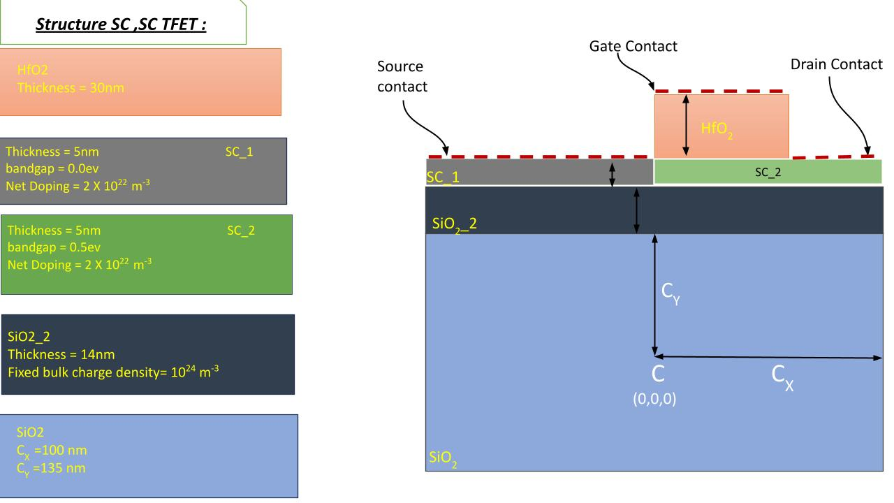

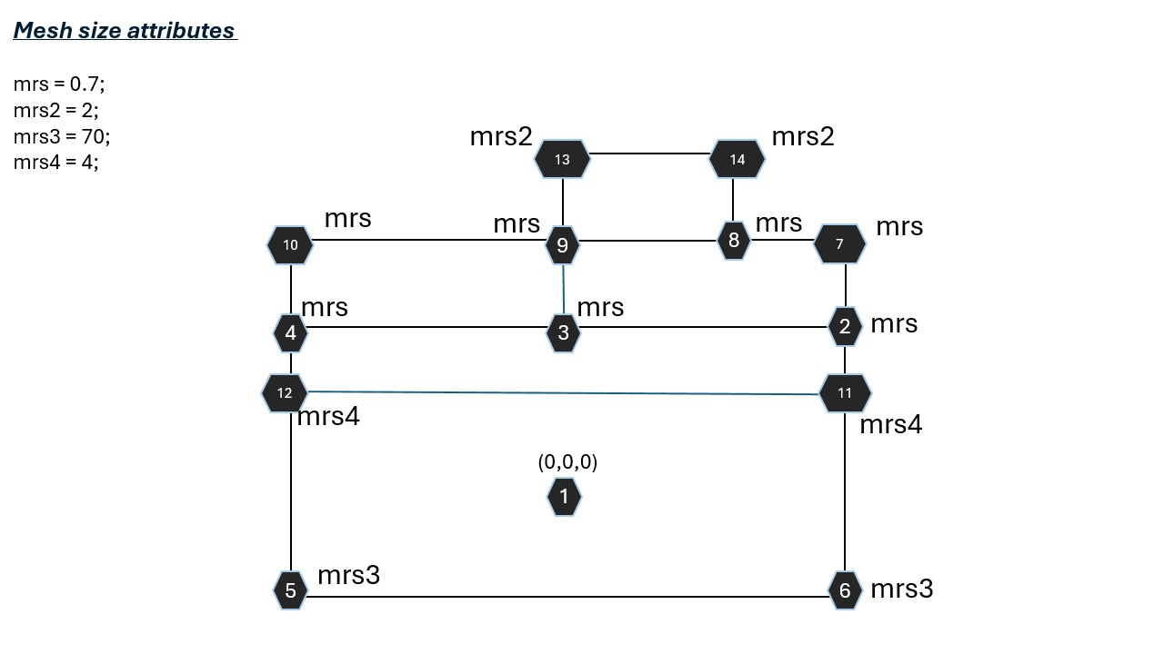

***Analyses for Conduction Band Off Set:***

**Paper1:**

Research paper title:

Band offsets and heterostructures of two-dimensional

semiconductors

reference: <http://dx.doi.org/10.1063/1.4774090>

**Conduction band Edge of different 2D materials :**

**These are the images taken from above mentioned research paper.**

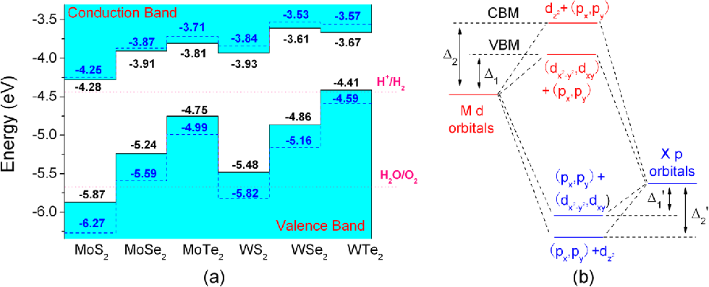

**Conduction band minimum (CBM) and Valence band maximum(VBM) for different layers:**

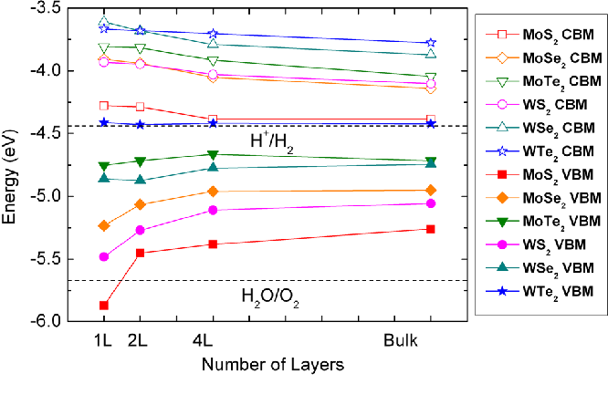

**Analyses1:**

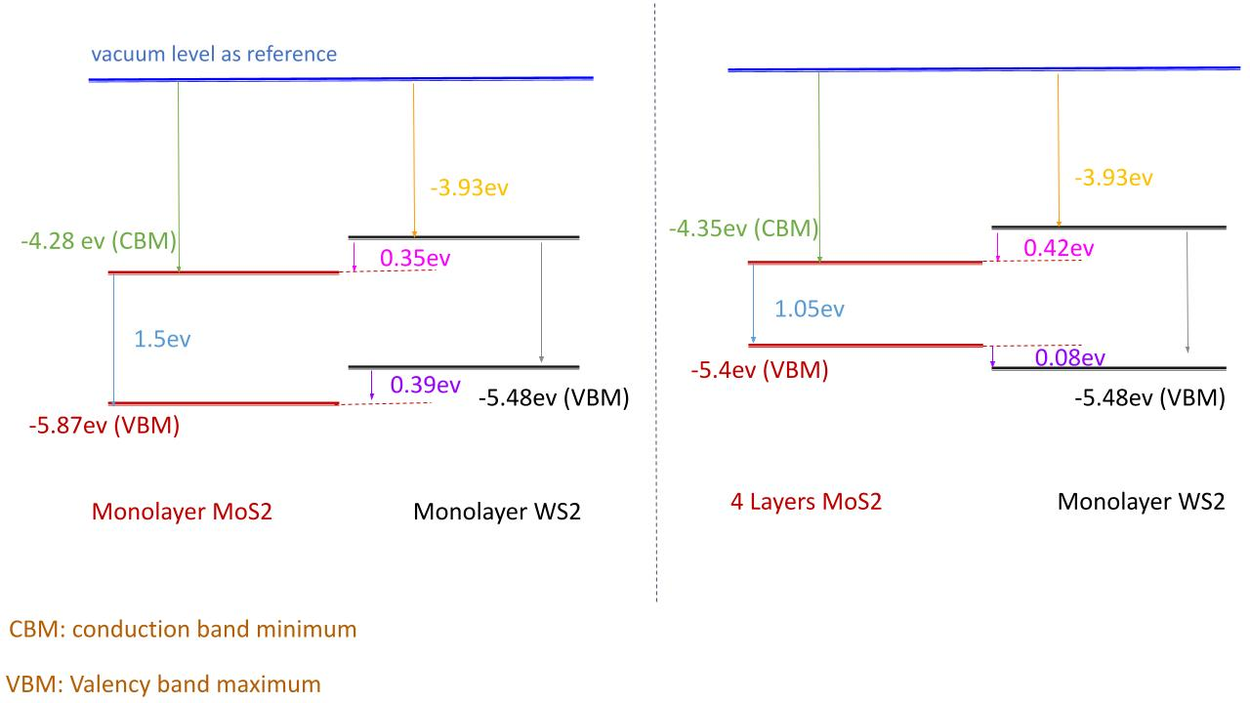

**Analyses2**

**In the below Analyses I consider two research papers**

**In the** [**http://dx.doi.org/10.1016/j.commatsci.2012.11.062**](http://dx.doi.org/10.1016/j.commatsci.2012.11.062) **their is how MoS2’s bandgap and work function is varying with thickness , accordingly come with a conclusion below for MoS2**

**For WS2 I considered the paper** [**http://dx.doi.org/10.1063/1.4774090**](http://dx.doi.org/10.1063/1.4774090) **whose diagrams are also mentioned for Analyses1.**

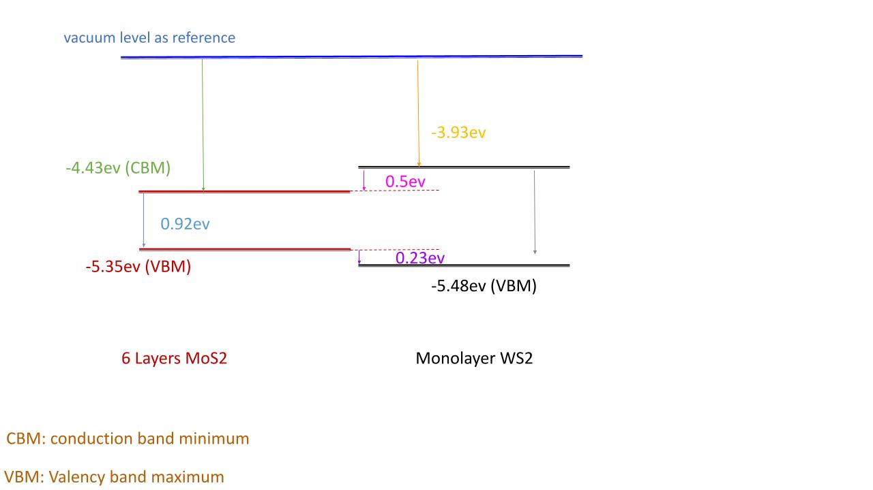

**Fermi level MoS2 with respect to different doping profiles:**

**Fermi level is pink dotted line .**

**Blue line and Orange line are Conduction band edges**

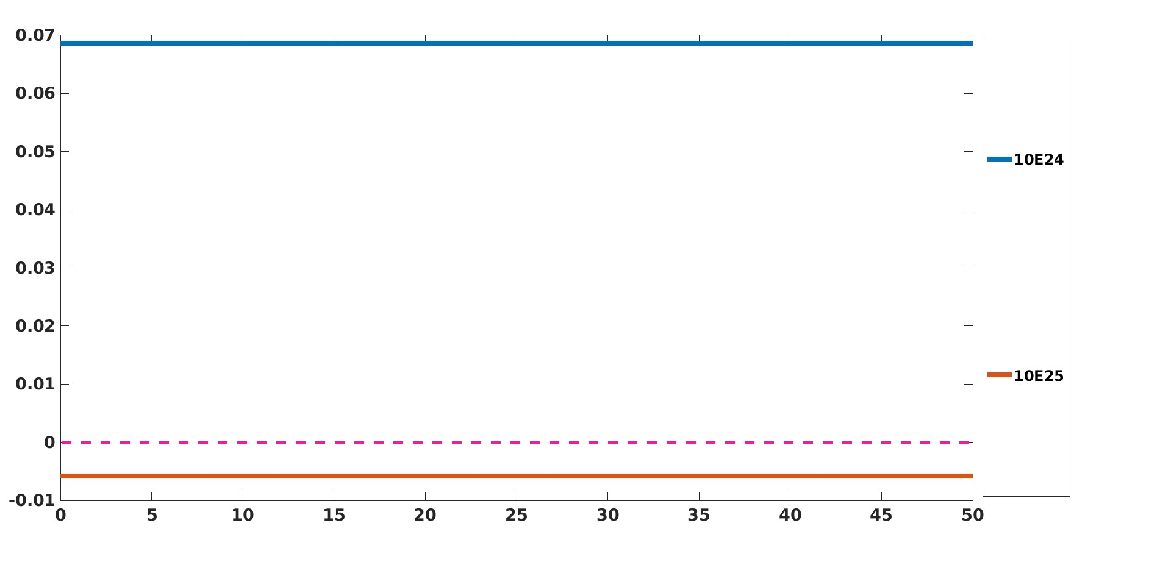

**Fermi level MoS2 with respect to different doping profiles:**

**Fermi level is at zero horizontal line.**

**Coloured lines are Conduction band edges**

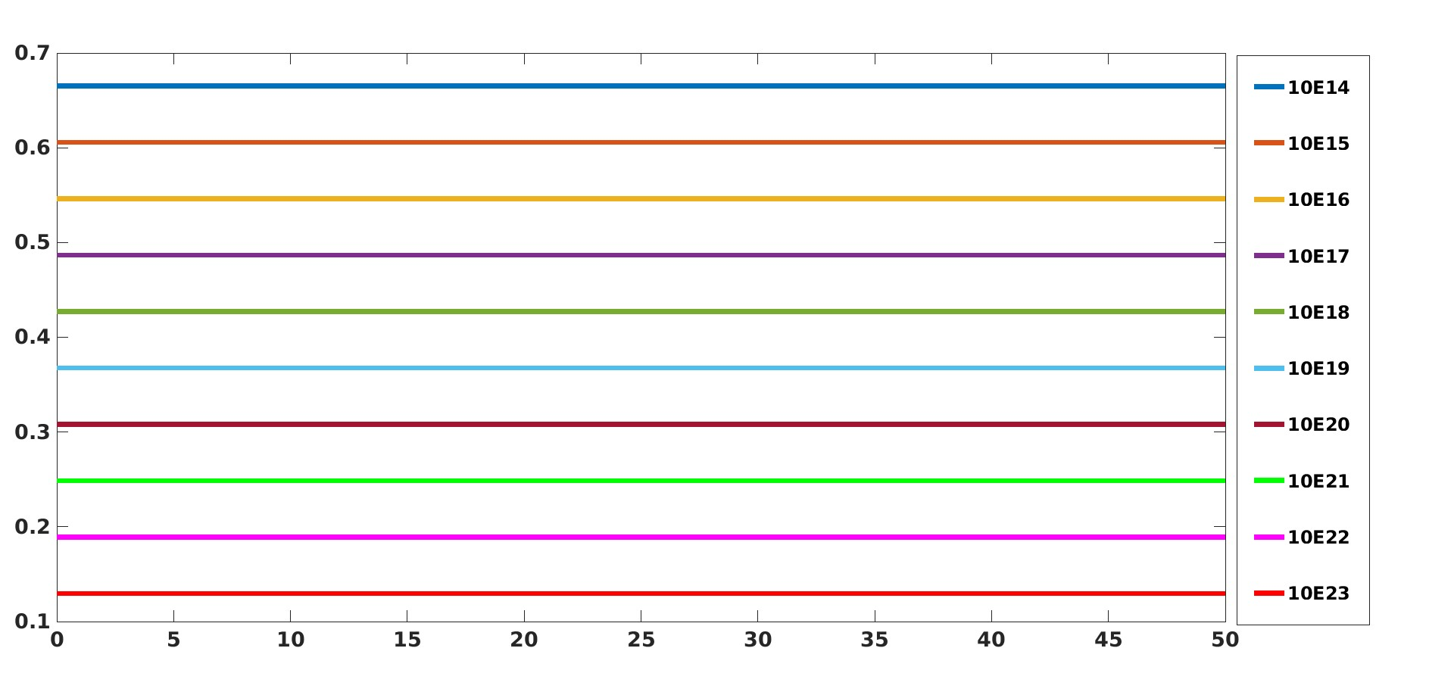

**Heterojuction diode**

**MoS2 with 50nm**

**WS2 with 75nm**

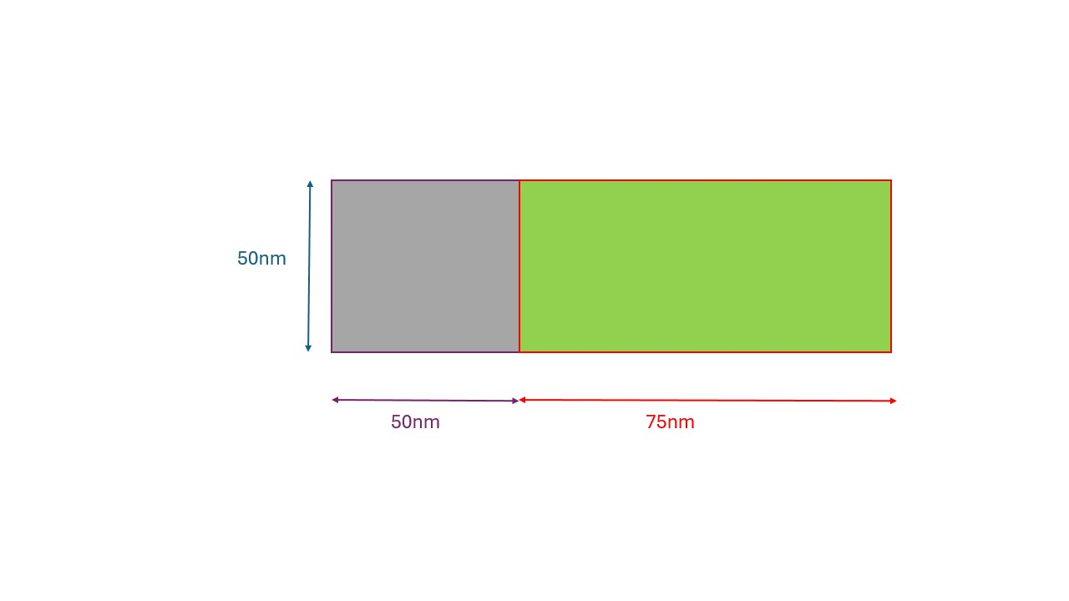**Heterojunction:**

**SC1 (MoS2) material properties:**

**MaterialType semiconductor**

**Permittivity 7.6**

**BandGap 1.1**

**ElectronDoSMass 0.71**

**ElectronTunnelMass 0.0**

**HoleDoSMass 0.0**

**HoleTunnelMass 0.0**

**HoleDoSMass 0.0**

**HoleTunnelMass 0.0**

**DeltaEc -0.5**

**NetDoping 1E24**

**SC1 (WS2) material properties:**

**MaterialType semiconductor**

**Permittivity 5.8 [Ref]**

**BandGap 1.7**

**ElectronDoSMass 0.71**

**ElectronTunnelMass 0.0**

**HoleDoSMass 0.0**

**HoleTunnelMass 0.0**

**DeltaEc 0.0**

**NetDoping 1E23**

**The below plot is the conduction band edge of Heterojunction diode for different doping profiles.**

**keeping SC1 doping 10e24 and varying SC2 doping from 10E12 to 10E14,**

**then from 10E20to 10E23**

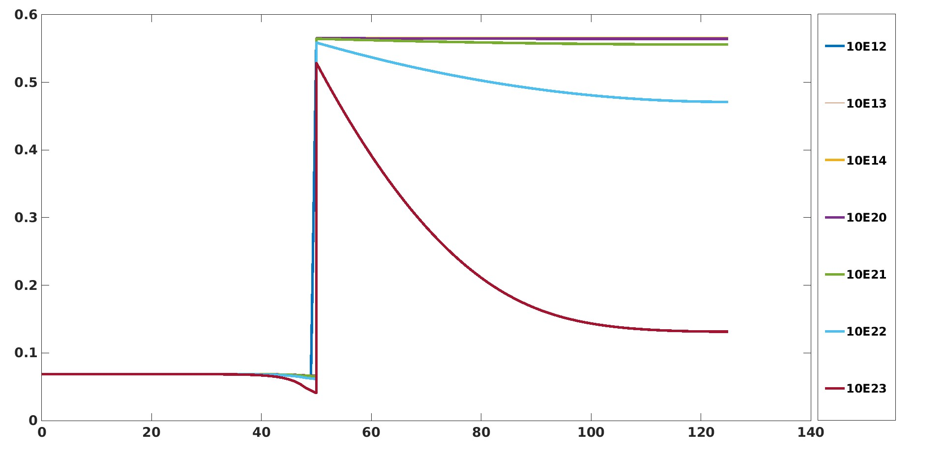

**Structure of 2D heterostructure Diode:**

**Doping of MoS2 = 10E24**

**Doping of WS2 = 10E23**

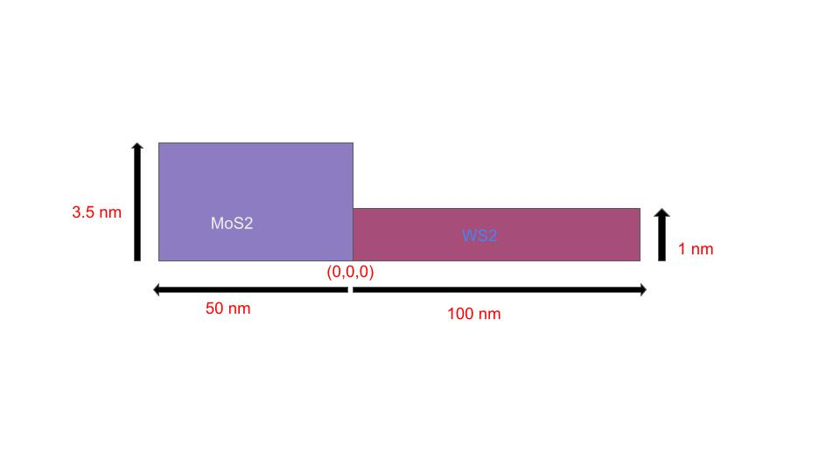

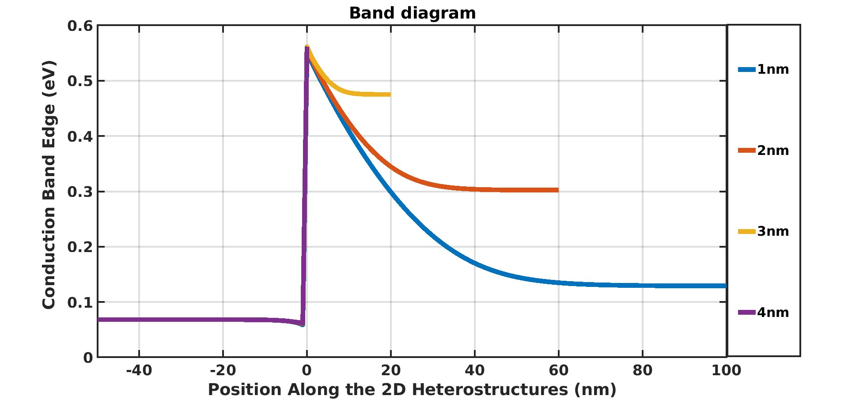

**This the Electrostatic potential while moving in vertical direction of above fig diode .**

**I analyze that there comes Electrostatic potential in the air as triangular(shown in blue color ) due to interpolation as shown below ;**

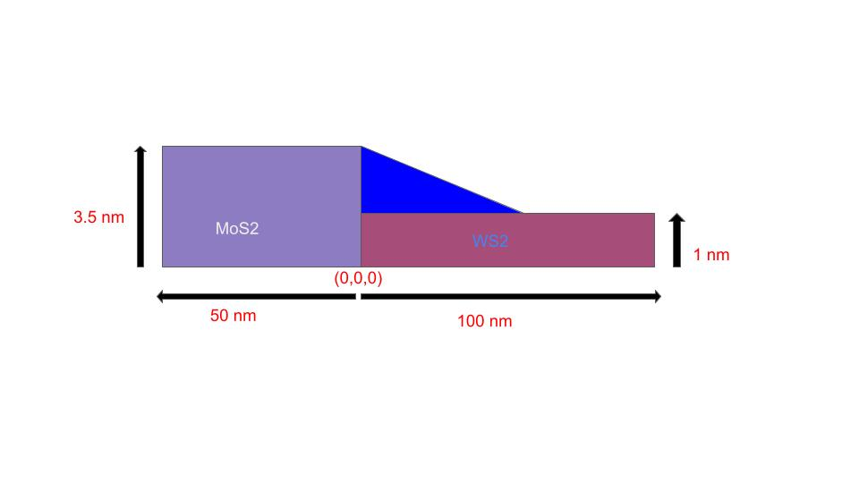

**To remove that I write a code to put electrostatic potential NaN there and then after the result is as follows :**

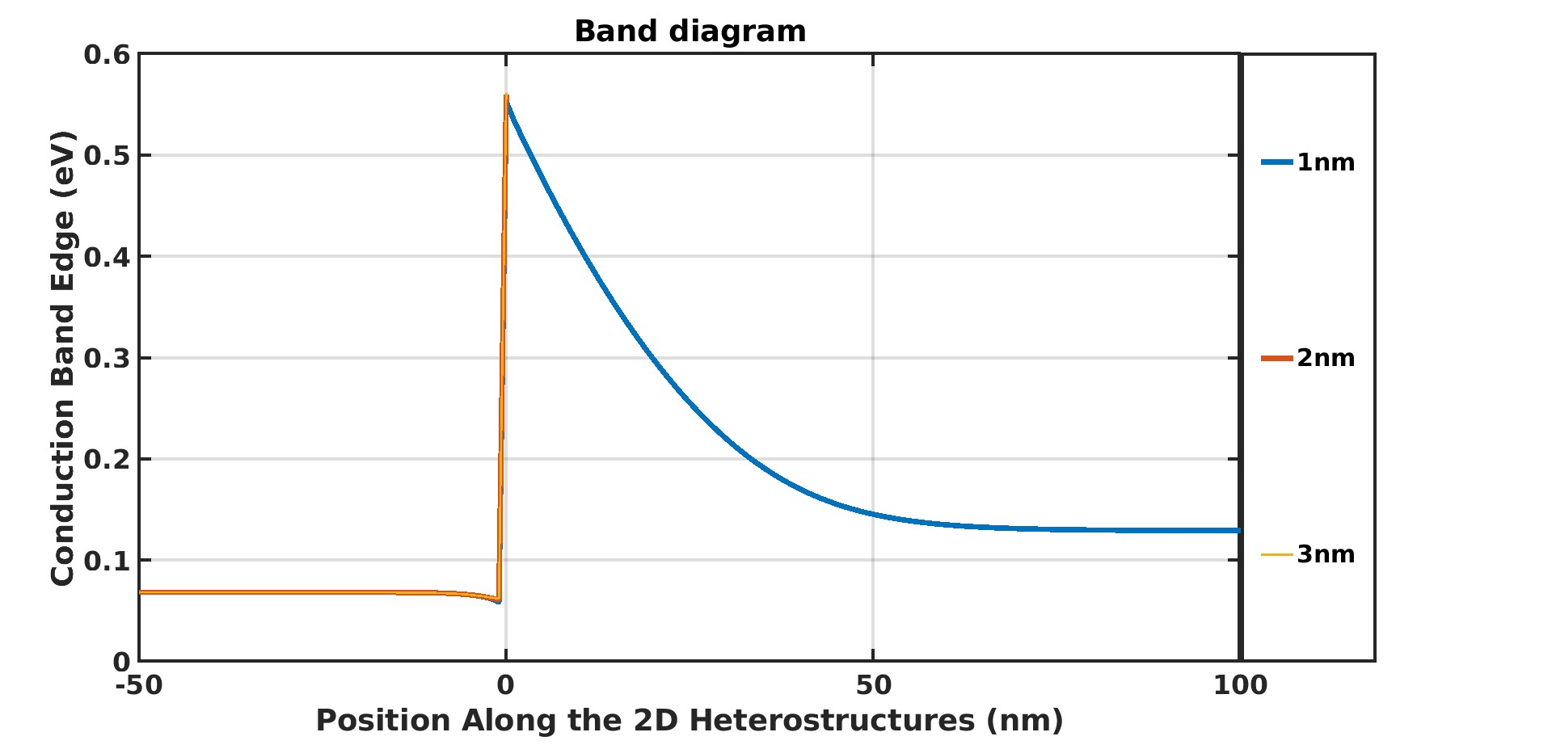

**On adding the SiO2**

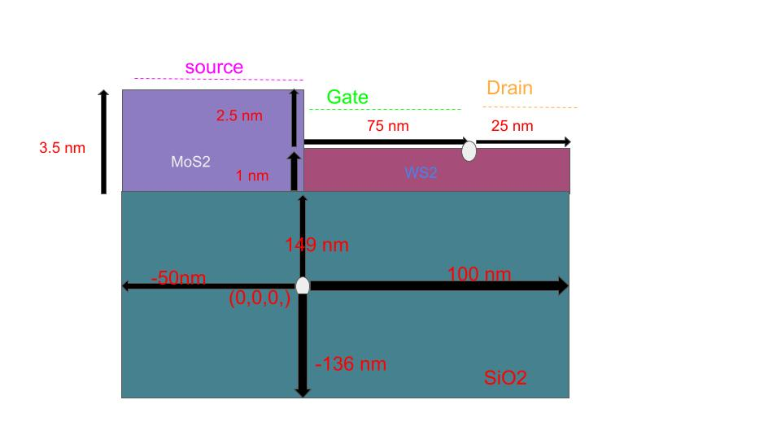

**While taking all the boundary conditions VNM**

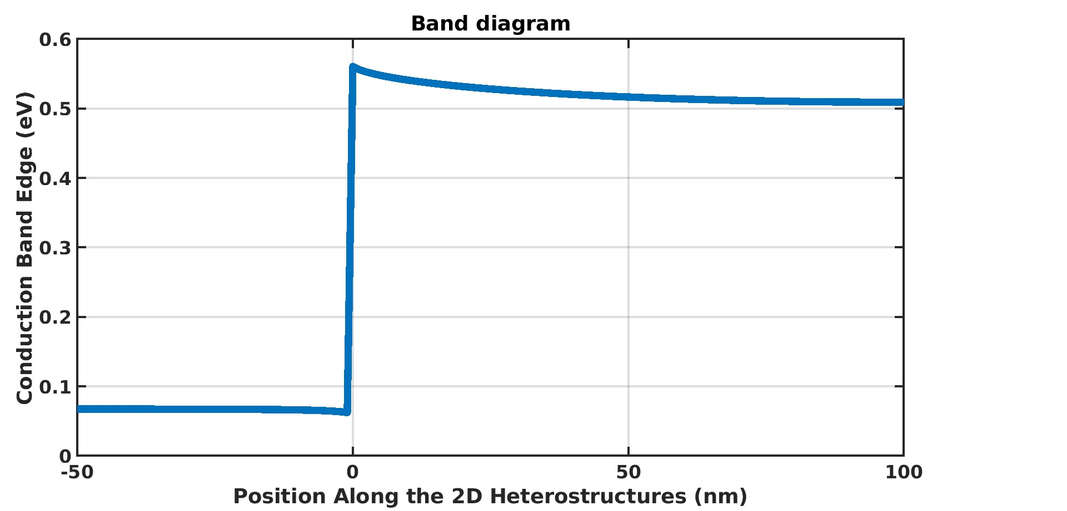

**While taking Source as ‘Source boundary conditions’ (3 million) and rest VNM BC.**

**The Conduction Band moves down as;**

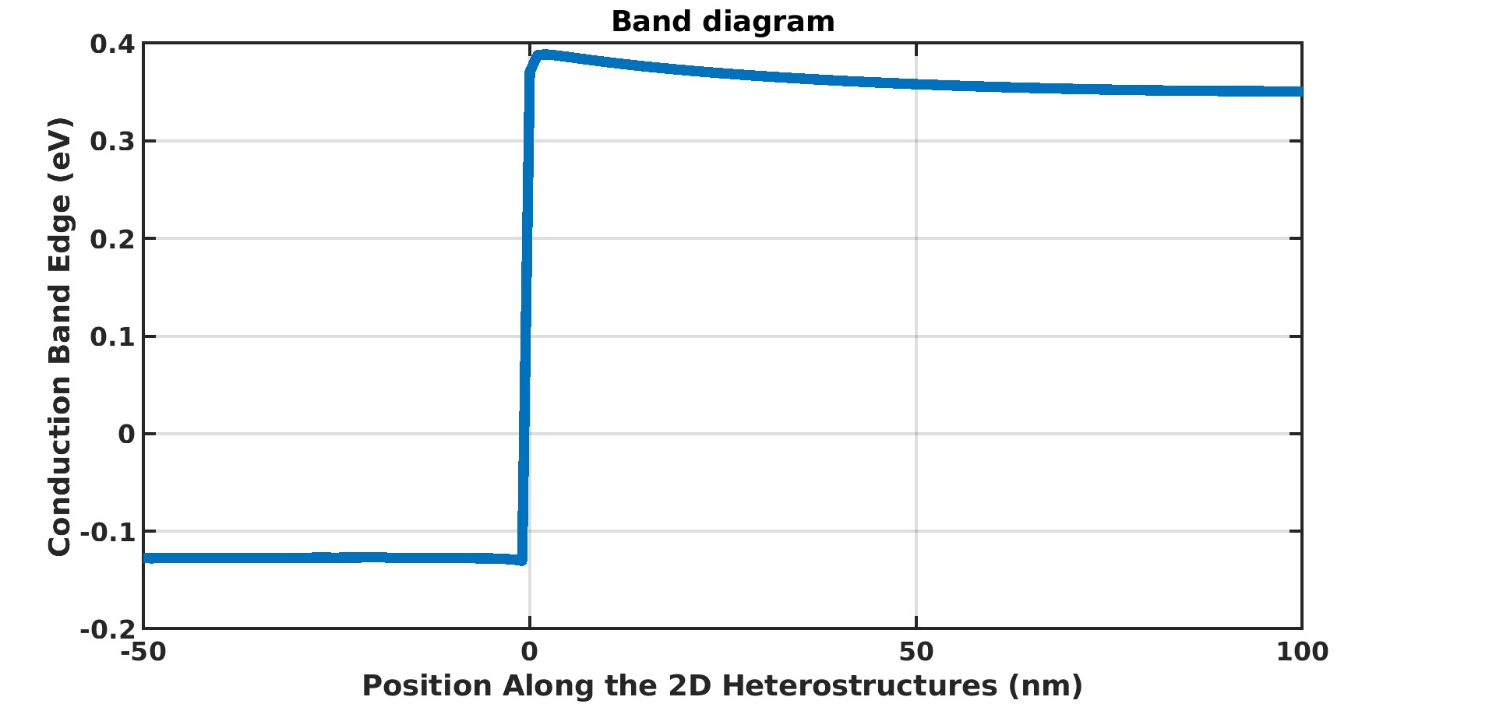

**While taking Source as ‘Source boundary conditions’ (3 Million), Drain as DBC (4 Million) and rest VNM BC.**

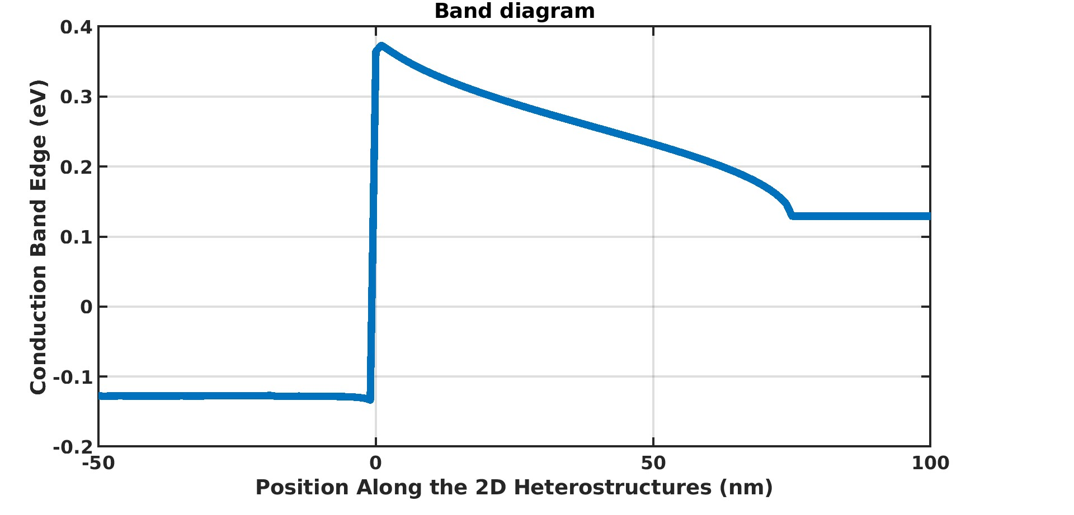

**Semiconductor and Semiconductor Diode**

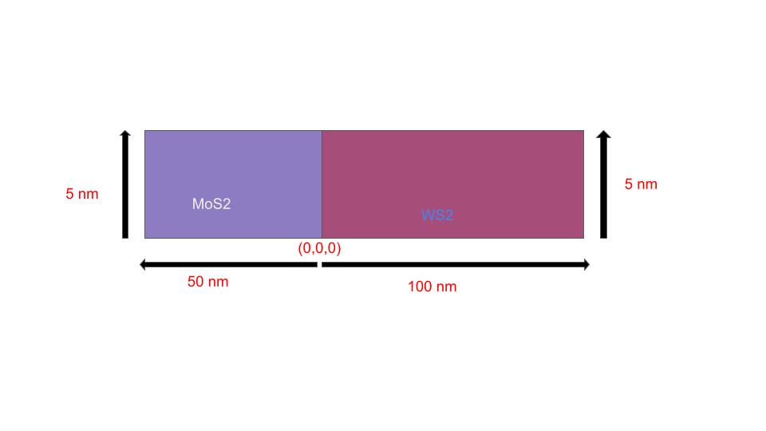

**Conduction band with different dopings with VNM Boundary Conditions**

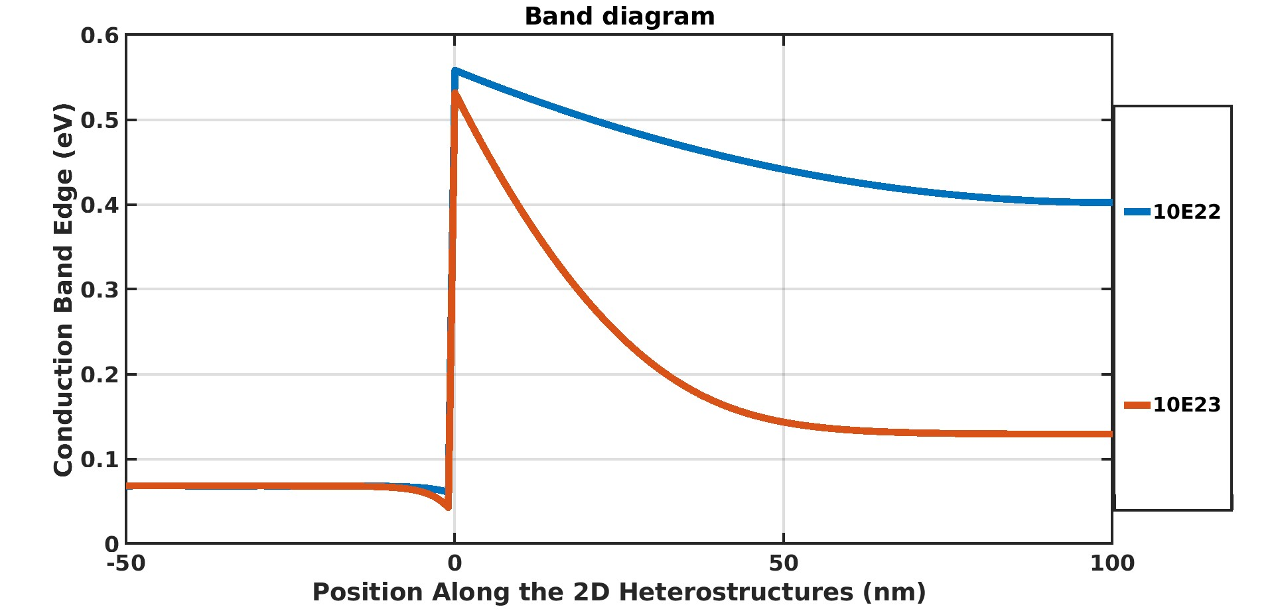

**SC1 = 1e24/ m-3**

**Conduction band with different dopings with source BC (MoS2) and VNM Boundary Conditions**

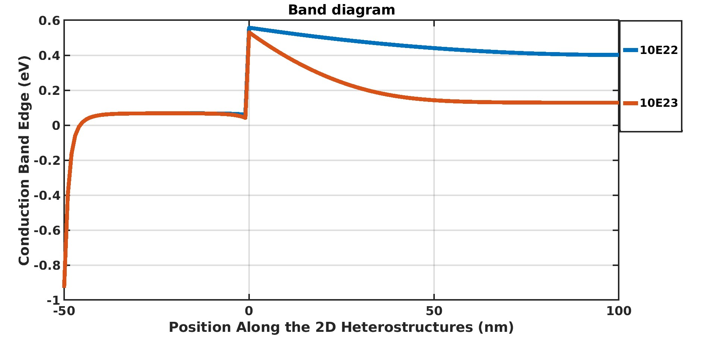

**Semiconductor ,Semiconductor and SiO2**

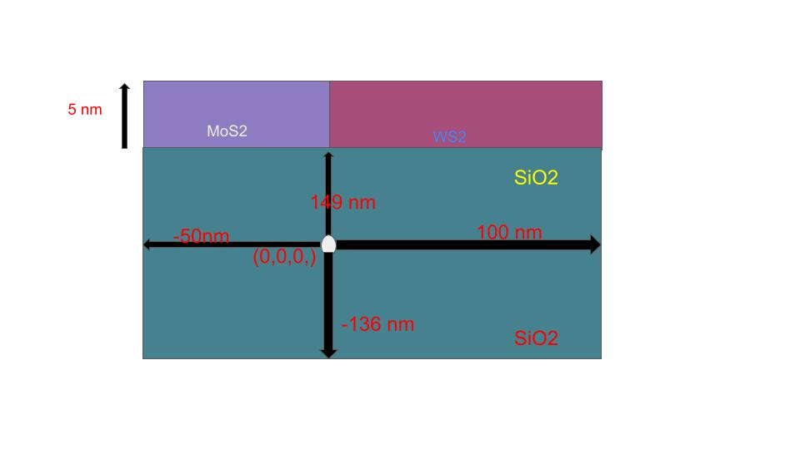

**CB with VNM Boundary Conditions**

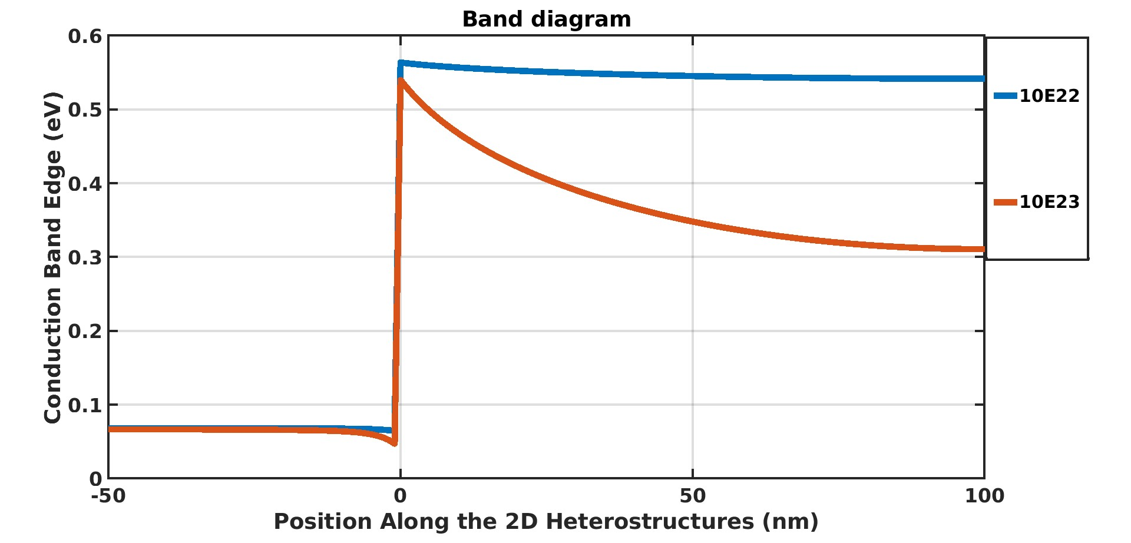

**CB with source and VNM Boundary Conditions**

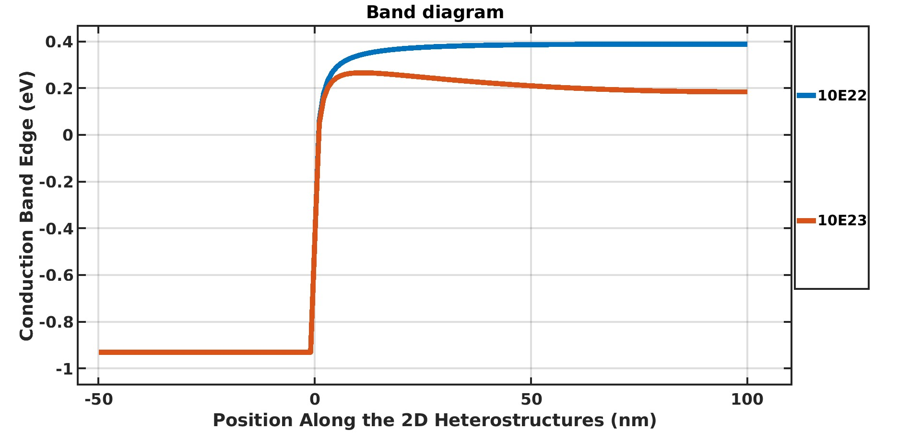

1. **Drain - Dir - Vs - 10mV Source is VNM**
2. **Please try 1 with MoS2 and WS2 ans 1 nm.**
3. **Keep 1 nm Gap b/w MoS2 (3.5 nm) and HfO2**

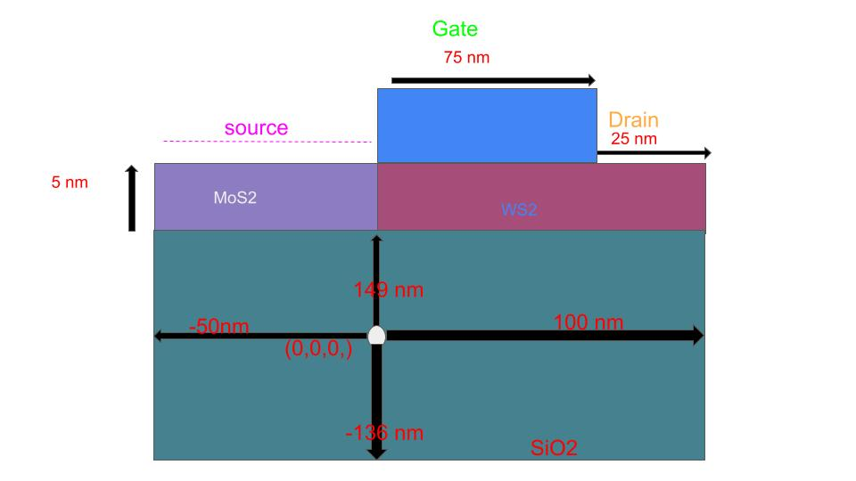

**All BC are VNM varying the vtgh**

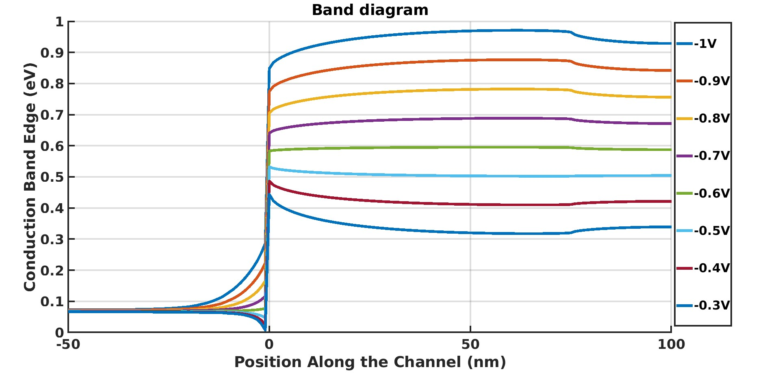

**Taking drain BC and rest VNM and then varying Vtg**

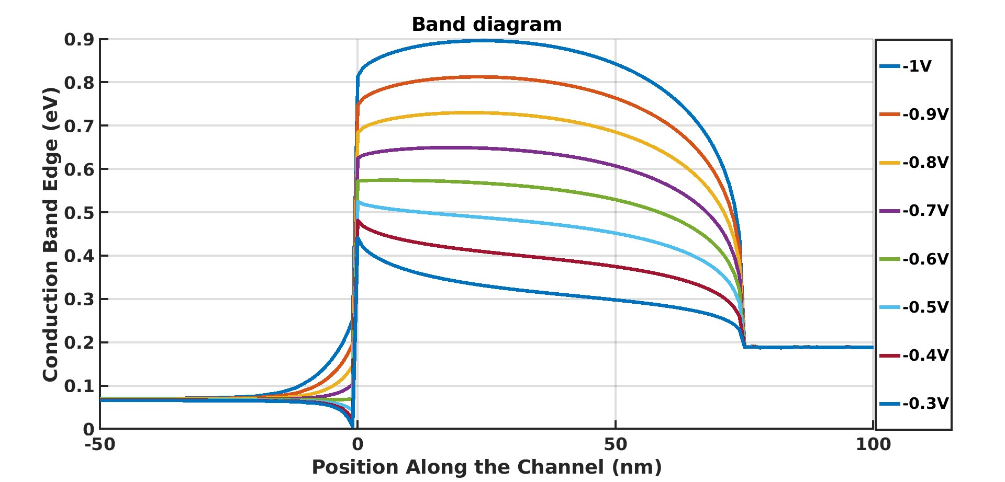

**Doping = 10E22**

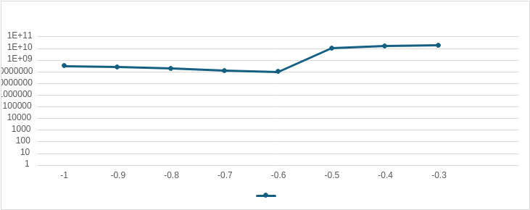

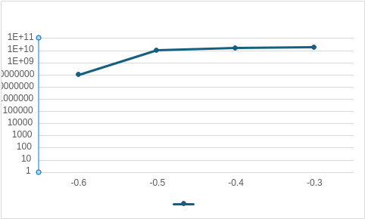

| **Vtg** | **Current (nA)** |
| --- | --- |
| **-1** | **324895641.8** |
| **-0.9** | **257662311.1** |
| **-0.8** | **191622050.8** |
| **-0.7** | **125755525.7** |
| **-0.6** | **99008057.19** |
| **-0.5** | **10571513529** |
| **-0.4** | **15769451282** |
| **-0.3** | **17960156514** |

**Doping = 10E23**

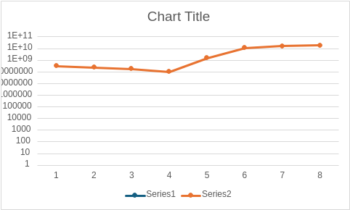

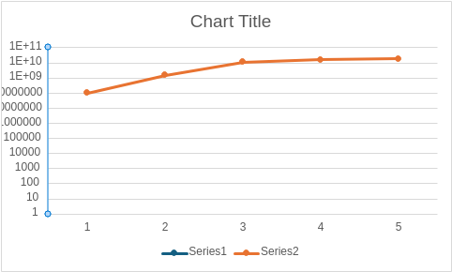

| **Vtg** | **current** |
| --- | --- |
| **-1** | **310631620.1** |
| **-0.9** | **239401552.9** |
| **-0.8** | **174075052.2** |
| **-0.7** | **101361274.9** |
| **-0.6** | **1490600680** |
| **-0.5** | **11573587461** |
| **-0.4** | **16193372231** |
| **-0.3** | **18054105329** |